Lab Review Activity (Pair Programming)

In the first part of this lab, you'll answer some questions and discuss your answers with a partner. In the second part, you'll create a new Java class and write code based on the given requirements.

**Part 1- Discussing Questions and Providing Answers**

1. Discuss these questions with your partner and answer the questions:
   1. Type a statement that will correctly converts the data type of either variable, if x is a float and y is a double?

Float = x

Double =y

Y = (double ) X

* 1. The Boolean data type may contain what range of values?

True and false

* 1. When this code is executed what occurs? If there is an error, how would you fix it? (**Hint**: Forever is a long time) the executed answer is forever is a long time because the numbers repeat forever. If there is an error put a break.

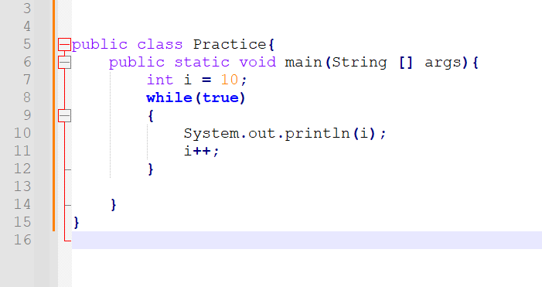

* 1. True or False: The do-while loop is ideal in situations where you always want the loop to iterate at least once?

true

**Part 2- Creating the ‘Budget’ Class**

1. Create a new class **Budget** that

• asks the user to enter the amount budgeted for a month

• uses a loop to prompt the user to enter each expense for the month (indeterminate number)

• keeps a running total of the expenses

• prints the budget, the total expenses, and the amount the user is over or under budget (expenses = budget would be considered under by 0)

**Submit this word document file** and the **Budget.java** with the names of your partners.